

Requirement & Design Specification
LocalStore POS
Version: 1.0

– Hanoi, January 2026 –

Record of Changes
Version | Date | A*  M, D | In charge | Change Description
*A - Added M - Modified D - Deleted

Contents
Record of Changes 2
I. Overview 5
1. System Context 5
2. External Entities 5
3. Business Processes 5
3.1 Sale Process 6
3.2 Customer Support 6
4. User Requirements 6
4.1 UCs for Guest 7
4.2 UCs for Student 7
4.3 … 7
5. System Functionalities 7
5.1 Screens Flow 7
5.2 Screen Authorization 8
5.3 Non-UI Functions 8
II. Functional Requirements 9
1. Feature Name1 9
1.1 SubFeature Name1.1 9
1.2 SubFeature Name1.2 9
2. User Authentication 9
2.1 User Register 9
3. System Administration 9
3.1 Master Data 9
3.2 User Management 10
III. System Design 11
1. Software Architecture 11
1.1 Overall Architecturural Diagram 11
1.2 Component Descriptions 11
2. Code Package Design 11
2.1. Package Diagram 12
2.2 Package Descriptions 12
3. Database Design 12
3.1 Database Schema 13
3.2 Table Descriptions 13

I. Overview

1. System Context
[Gives the overall description about the product with some introduction and the context diagram. The context diagram presents the boundary and connections between the system you’re developing and everything else in the universe. This identifies external entities (or terminators – software, hardware, human components, and other systems) outside the system that interface to it in some way, as well as data, control, and material flows between the terminators and the system.]
LocalStore POS is a web-based Point of Sale system designed to provide comprehensive management for small to medium-sized retail or convenience stores.
The system operates locally and offline on a computer within the store, ensuring fast processing speed, high stability, and uninterrupted operation without dependence on an internet connection.
LocalStore POS supports core retail activities such as sales transactions, product and inventory management, customer handling, and sales reporting.
By centralizing daily store operations into a single system, LocalStore POS helps store owners and staff improve efficiency, reduce manual errors, and maintain accurate business records.
The system is intended to be simple, reliable, and suitable for stores with limited technical resources while still covering essential business needs.
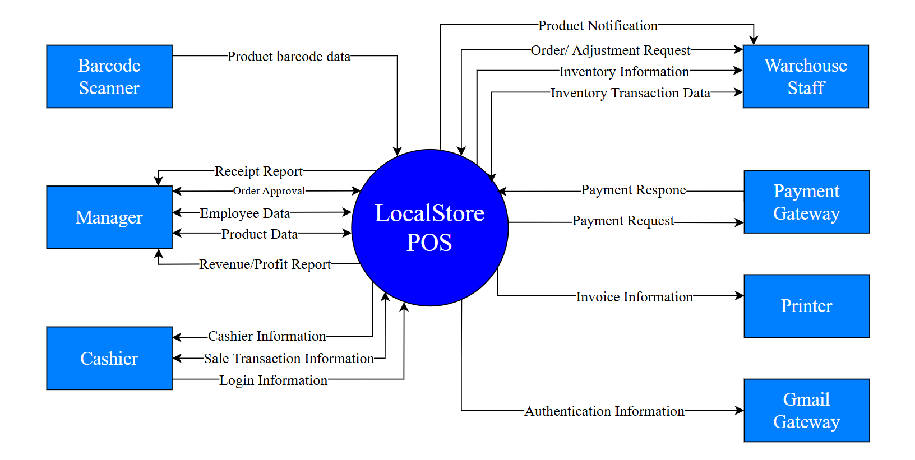

2. External Entities
[Describe the external entities who/what might interact with your system as mentioned in the context diagram above, using the form of table as following]
# | Entity | Description
1 | Manager | A user role responsible for overseeing store operations. The manager interacts with the system to view revenue reports, approve orders, manage employee data, and maintain product information.
2 | Warehouse Staff | A human external entity responsible for managing inventory and stock-related activities.  The warehouse staff exchanges inventory information and inventory transaction data with the LocalStore POS system to ensure accurate stock levels and proper inventory control.
3 | Cashier | A human external entity responsible for conducting daily sales operations at the store.  The cashier interacts directly with the LocalStore POS system to log in, process sales transactions, and handle customer payments.  The cashier provides sales transaction data and login credentials to the system and receives transaction results and relevant sales information in return.
4 | Barcode Scanner | A hardware external entity used during sales transactions.  It scans product barcodes and sends product barcode data to the LocalStore POS system.  This allows the system to quickly identify products, retrieve pricing information, and add items to sales transactions.
5 | Payment | An external payment service or payment handling component.  It receives payment requests from the LocalStore POS system and returns payment information after processing transactions.  This entity enables the system to complete payment processing as part of the sales workflow.
6 | Printer | A hardware external entity used to print invoices and receipts.  The LocalStore POS system sends invoice information to the printer, which outputs physical receipts for customers after successful transactions.
7 | SMS/Gmail Gateway | An external communication service used to send authentication or notification messages (such as OTPs or alerts) to users via SMS or email.

3. Business Processes
[Provide business processes () using the swim-lane diagram(s) like sample below
A business process a collection of activities that takes one or more kinds of input and creates an output that is of value to the customer. The customer for a business process may be a traditional external customer (the person who buys the finished product), or it may be an internal customer (such as a colleague in another department)]

3.1 Sale Process
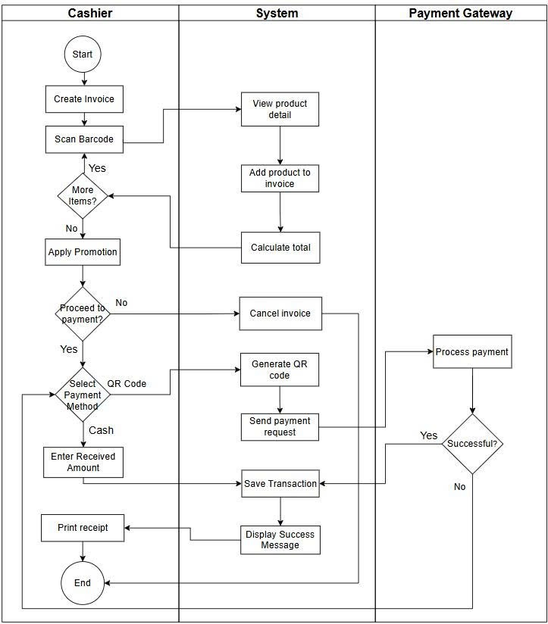

3.2 Import Goods
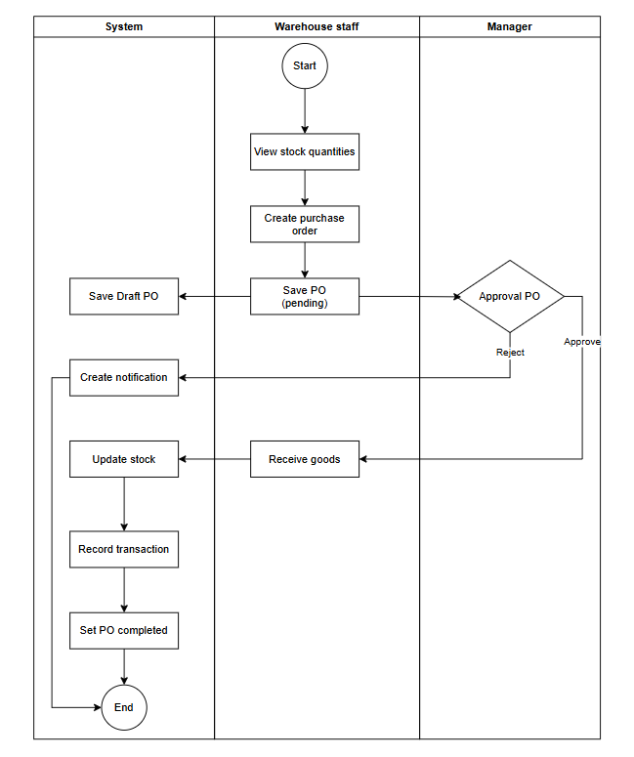

4. User Requirements
In this section, you need to provide the descriptions for all the use case (UC) you would have identified (in the form of table), and UC diagram(s) to show the actor-UCs and UC-UC relationships (like the sample below] – just one consolidated diagram or multiple diagrams for the system, each diagram is for one actor or one workflow]

ID | Use Case | Feature | Main Actor | Use Case Description
1 | Create Invoice |  | Cashier | Create a new sales invoice when a customer starts a purchase. The system initializes an empty invoice with a unique invoice ID, timestamp, cashier information, and default status.
2 | Add Product to Invoice (Barcode/Mannual) |  | Cashier | Add products to the invoice by scanning a barcode or entering product information manually.
3 | Update Invoice Item |  | Cashier | Modify invoice items by updating quantities, removing items, or correcting item details before payment is processed.
4 | Input Customer Information |  | Cashier | Assign a customer to the invoice by selecting an existing customer or entering customer information. Customer data is used for promotions, loyalty points, and invoice history tracking.
5 | Use Promotion |  | Cashier | Apply applicable promotions, vouchers, or discounts to the invoice based on promotion rules.
6 | Process Payment |  | Cashier, Payment Gateway | The system supports calculating the total amount after discounts/taxes and handles multiple payment methods (cash, bank transfer via ZaloPay QR).
7 | Print Receipt |  | Cashier, Printer | Print or display the payment receipt after a successful transaction. The receipt includes invoice details, payment method, and transaction information.
8 | Cancel Invoice |  | Cashier | Cancel an unpaid invoice when the customer decides not to proceed with the purchase. The system marks the invoice as canceled and prevents further processing.
9 | View Invoice History |  | Manager | View a list of past invoices with filtering and search options based on date, cashier, customer, or payment status.
10 | Cancel QR Payment |  | Cashier | Cancel a pending QR payment when the customer switches to another payment method or when the QR code expires. The system invalidates the QR transaction request.
11 | Refund Process |  | Cashier | The cashier reviews the refund eligibility based on the customer's old receipt or verifies the paid receipt (based on customer information). Based on predefined business rules.
12 | Exchange Process |  | Cashier | Customers can exchange goods if the product they purchased has a problem. Based on predefined business rules.
13 | Record Refund/Exchange Invoice Detail |  | Cashier, Manager | Record and store detailed information related to refund or exchange transactions for tracking, reporting, and audit purposes.
14 | View Product Detail |  | Cashier | Display detailed product information, including price and inventory status, when a product is scanned or selected.
15 | Hold / Resume Invoice |  | Cashier | The cashier can process multiple bills at the same time. If a customer is having trouble paying, they can hold that order and process the payment for the next customer.
16 | Auto-confirm Bank Transfer |  | System, Payment Gateway | The POS system automatically displays "Success" and prints the receipt.
17 | View Stock Level |  | Manager, Warehouse Staff | Views current stock levels of all products, including quantity on hand, unit, and stock status.
18 | Create Purchase Order |  | Warehouse Staff | Warehouse staff creates a purchase order by selecting supplier, products, and quantities when stock needs to be replenished.
19 | Create Stock Adjustment Request |  | Warehouse Staff | Warehouse staff submits a request to adjust inventory quantities when discrepancies are found during stock checking.
20 | Approve Purchase Order |  | Manager | Manager reviews and approves purchase orders before they are sent to suppliers.
21 | Adjust Stock |  | Manager | Manager adjusts stock quantities based on approved adjustment requests or audit results.
22 | Confirm Goods Receipt |  | Warehouse Staff | Warehouse staff confirms that goods have been received from suppliers and the system automatically updates inventory quantities.
23 | View Receiving Report |  | Manager | Manager views weekly or monthly reports of received goods and purchase orders based on import transactions.
24 | Submit report problematic goods |  | Warehouse Staff | Warehouse Staff generate report to the manager when products or batches received are defective or have issues.
25 | Low Stock Alert |  | System | The system monitors stock levels and sends notifications when product quantities fall below the minimum threshold.
26 | Cancel Purchase Order |  | Manager | Manager cancels a purchase order when goods are not delivered or cannot be received, and the system notifies warehouse staff
27 | Notify report problematic goods |  | System | The system automatically sends a notification to the manager when a report problematic goods is submitted by warehouse staff.
28 | View Purchase Orders |  | Manager, Warehouse Staff | Warehouse staff and manager view the list of purchase orders that have been created or submitted, including order status and details.
29 | View Adjustment Request |  | Manager, Warehouse Staff | Warehouse staff and manager view the list of adjustment request that have been created or submitted, including order status and details.
30 | Create Category |  | Manager | Allows the manager to create a new product category to organize and classify products in the system.
31 | Update Category |  | Manager | Allows the manager to modify information of an existing product category, such as name, description, or status.
32 | Delete Category |  | Manager | Allows the manager to remove a product category from the system.
33 | Create Product |  | Manager | Allows the manager to create a new product with basic information including name, product code, category, unit, and selling price.
34 | Delete Product |  | Manager | Allows the manager to remove a product from the system.
35 | Update Product |  | Manager | Allows the manager to update information of an existing product, such as name, description, category, unit, or barcode.
36 | Create Combo |  | Manager | Allows the manager to create a new combo with from multiple products with varying quantities.
37 | Update Product Status |  | Manager | Allows the manager to change the status of a product (Active, Inactive, or Stop Selling).
38 | Manage Price |  | Manager | Allows the manager to set and update product pricing information, including selling price and cost price.
39 | Manage Barcode |  | Manager | Allows the manager to assign, update, and maintain product barcodes during product setup and maintenance.
40 | View Product List |  | Manager, Cashier | Allows manager and cashier to view the list of available products along with basic product information for daily operations.
41 | View Product Detail |  | Manager, Cashier | Allows users to view detailed information of a selected product, including category, price, barcode, and current status.Allows the user to view detailed information of a product.  Managers can view all product information, while cashiers can only view limited information required for sales.
42 | View Price History |  | Manager | Allows the manager to view the history of price changes for a product.
43 | Manage Unit Conversion |  | Manager | Allows the manager to define and manage unit conversion rules for products
44 | Register New Member |  | Staff | Allows staff to register a new customer account using their phone number as the unique identifier.
45 | Update Customer Info |  | Staff | Allows staff to search for a customer by phone number and update their personal information.
46 | View Purchase History |  | Staff | Allows staff to lookup a customer by phone number to view their past transaction history.
47 | Accumulate Loyalty Points |  | System | The system automatically adds loyalty points to the account associated with the provided phone number after a transaction.
48 | Auto-Update Membership Tier |  | System | The system automatically evaluates and upgrades membership tiers (e.g., Silver, Gold) based on total spending linked to the phone number.
49 | Create Promotion Programs |  | Manager | Allows the manager to configure new promotion campaigns, including name, duration, and discount type.
50 | Assign Products to Promotion |  | Manager | Allows the manager to assign specific products or product categories to a promotion campaign.
51 | Create & Manage Vouchers |  | Manager | Allows the manager to generate voucher codes and set usage conditions (e.g., expiration date, minimum order value).
52 | Validate & Apply Voucher |  | Cashier | Allows the cashier to validate voucher authenticity and apply the discount to the current order.
53 | View Promotion Reports |  | Manager | Allows the manager to view performance reports analyzing the revenue impact of promotion campaigns.
54 | View Voucher Usage Reports |  | Manager | Allows the manager to track statistics on the number of vouchers issued versus those redeemed by customers.
55 | View Staff List |  | Manager | Allows the manager to view a list of all staff members including basic information such as name, position, employment status, and account status.
56 | Create Staff Infomation & Account |  | Manager | Allows the manager to create a new staff profile including personal information, position/role, employment type, and initial employment status, create account email, password for staff.
57 | Update Staff Information |  | Manager | Allows the manager to update staff personal or employment information such as position, working type, or employment status (active, resigned).
58 | Change Staff Account Status |  | Manager | Allows the manager to activate, deactivate, or lock a staff system account to control system access.
59 | Login |  | Manager,Cashier,Warehouse | Allows users to authenticate into the system using their email/username and password to access authorized functions.
60 | Logout |  | Manager,Cashier,Warehouse | Allows users to securely log out and terminate their current system session.
61 | Forgot Password |  | Manager,Cashier,Warehouse | Allows users to reset their password by requesting a one-time password (OTP) or reset link sent via email/SMS gateway.
62 | Create Work Shift |  | Manager | Allows the manager to define work shifts including shift date, start time, end time, and shift type.
63 | Assign Staff to Shift |  | Manager | Allows the manager to assign eligible staff members to work shifts while checking role compatibility and schedule conflicts.
64 | Check In for Shift |  | Cashier, Warehouse | Allows staff to check in at the beginning of their assigned shift to record attendance start time.
65 | Check Out from Shift |  | Cashier, Warehouse | Allows staff to check out at the end of their shift to record attendance end time and calculate working duration.
66 | Notify Shift Ending |  | System | Automatically sends notifications to staff when their shift is about to end to prepare for check-out and cash handover.
67 | Record Shift Cash Log |  | System | Automatically records cash inflow and outflow during a working shift.
68 | Cash Handover |  | Cashier | Allows staff to hand over actual cash at the end of their shift.
69 | Calculate Staff Salary |  | System | Automatically calculates staff salary based on total working hours, attendance records, and salary rules.
70 | View Salary Report |  | Manager | Allows the manager to view payroll reports including working hours and calculated salary for each staff member.
71 | View Cash Handover Report |  | Manager | Allows the manager to view reports comparing expected cash and actual cash handed over across shifts.

4.1 UCs for Manager

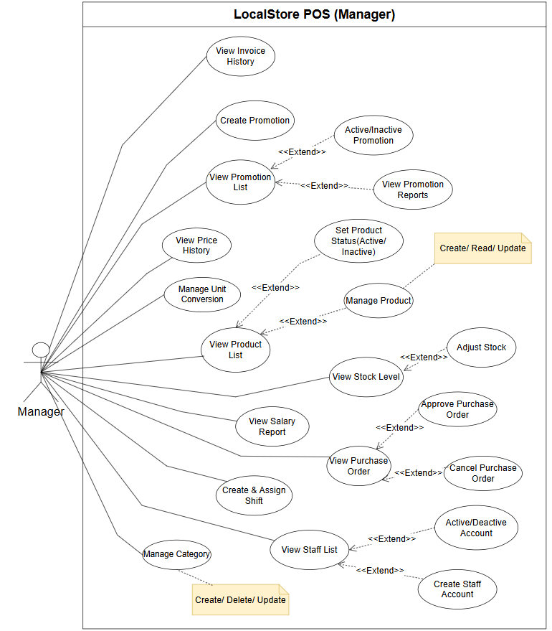

4.2 UCs for Cashier
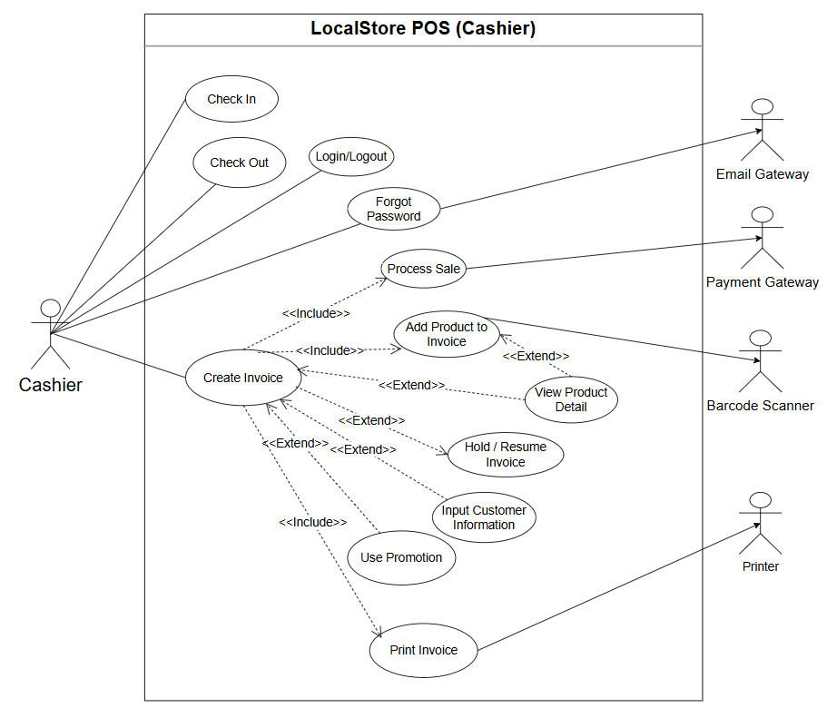

4.3 UCs for Warehouse Staff

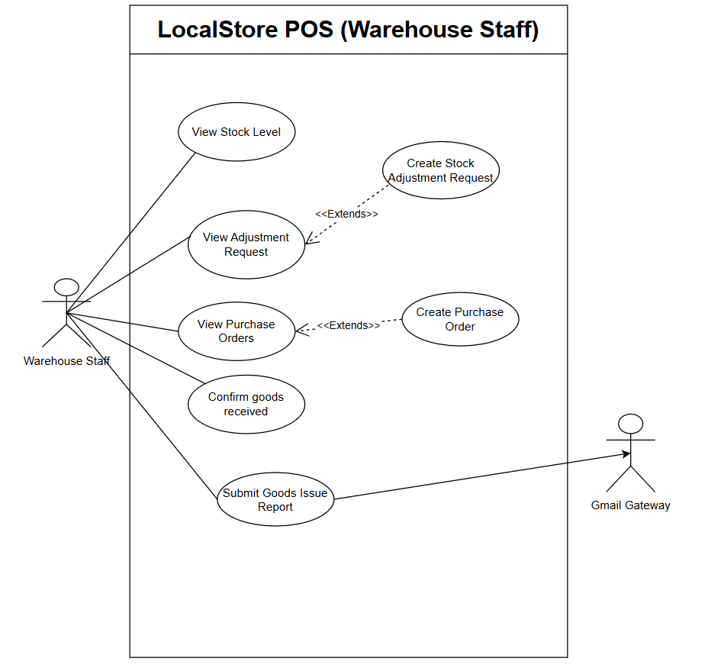

5. System Functionalities
[Provide functionality overview of software system: screen flow, screen descriptions, system user roles, screen authorization, non-screen functions, ERD]

5.1 Screens Flow
[This part shows the system screens and the relationship among screens. You can draw the Screens Flow for the system in the form of diagram as below.]
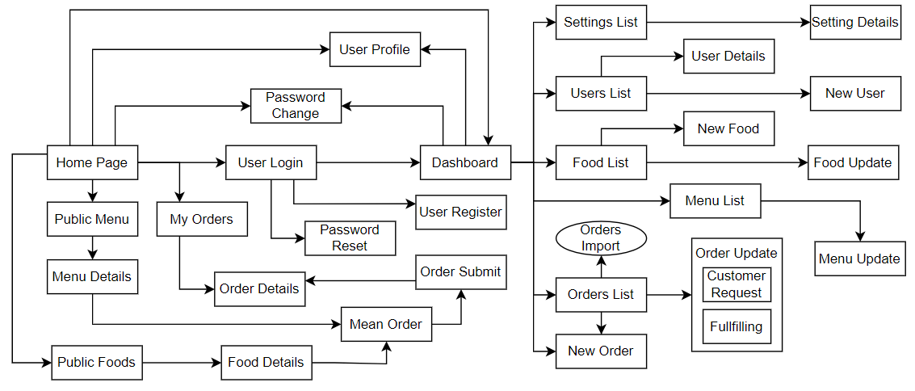

5.2 Screen Authorization
[Provide the system roles authorization to the system features (down to screens, and event to the screen activities if applicable) in the table form as below – replace Role-Name1, Role-Name2,… with your specific system user role names]
Screen | Role-Name1 | Role-Name2 | Role-Name3 | …
<<Screen Name1>> | X |  | X | X
<<Screen Activity>> |  |  | X | X
<<Screen Name2>> | X |  | X
Query All Data | X
Query Own Data |  |  | X
Add New Data |  |  | X | X
Update All Data |  |  |  | X
Update Own Data |  |  |  | X
Delete Data
…

5.3 Non-UI Functions
[Provide the descriptions for the non-screen system functions, i.e batch/cron job, service, API, etc.]
# | Feature | System Function | Description
1 | <<Feature Name>> | <<Function Name1>> | <<Function Name1 Description>>
2 | …

II. Functional Requirements
[Provide descriptions about the system’s functions/screens. The functions/screens are grouped by the system features, and even sub-features if needed. For the screens, you need to provide the screen layouts (mock-up screens) and relevant specifications if needed]

1. Feature Name1

1.1 SubFeature Name1.1

1.1.1 Screen/Function Name1
[Content #1: UI layout (Mockup screen prototype)]
[Content #2: brief descriptions of the screen/function, mapped to the relevant use cases]
[Content #3: provide further descriptions for the screen’s components/fields using table format below]
Field Name | Description
Field Name1 | Field description: data type min/max length or value, initial data, etc.
Field Name2 | …
Field Group-Name1
Field Name3 | …
Field Name4 | …
Field Group-Name2
… | …

1.1.2 Screen/Function Name2
…

1.2 SubFeature Name1.2
…

2. User Authentication

2.1 User Register
…

3. System Administration

3.1 Master Data

3.1.1 Setting List
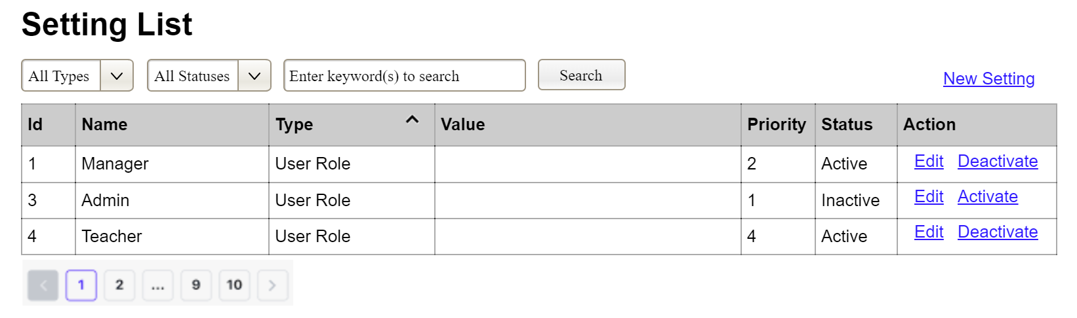
(1)
(2)
(3)
This screen allows the Administrator to:
- View Setting List: view list of current master data.
- Filter Setting List: filter master data by data types, statuses
- Search Settings: enter keyword(s) to search master data by their names or values
- Sort Setting List: sort mater data list (ascending, descending) by clicking column headers
On the screen, s/he can also
- Activate/Deactivate Setting: change status of a specific inactive/active master data
- Choose to go to the Setting Details screens for adding new or updating an existing master data by clicking the New Setting or Edit link.
Field Description
Field Name | Description
(1) | Initial values: all the active setting names with null or blank type  Hover the mouse to show the field name: “Setting Type”
(2) | Initial values: All Statuses, Active, Inactive (default value “All Status”)  Hover the mouse to show the field name: “Setting Status”
(3) | The change-status action is Activate or Deactivate depending on the current status of the relevant setting (Inactive or Active, respectively).

3.1.2 Setting Details
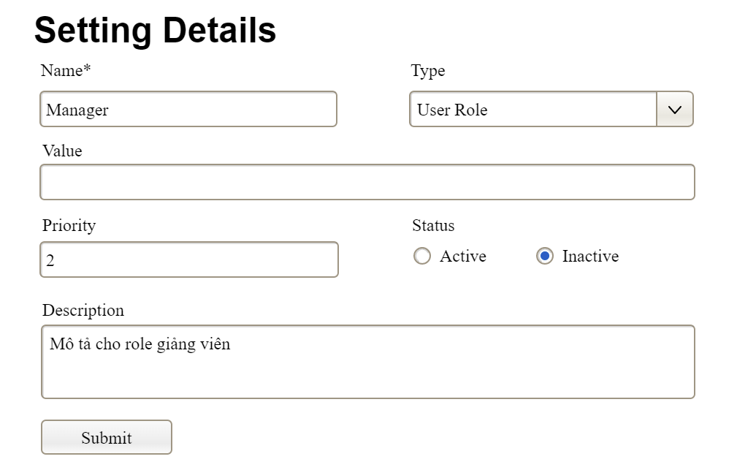
This screen allows the Administrator to:
- Add New Setting: add new master data.
- Update Setting Details: update details of a specific master data
Field Description
Field Name | Description
Name | Data type: non-digit string, max length of 20 characters
Type | Initial data values: all active setting names (with null or blank type)
Value | Data type: any string, max length of 100 characters
Priority | Data type: a positive integer
Description | Data type: any string, max length of 200 characters

3.2 User Management

3.2.1 User List
…

III. System Design

1. Software Architecture
[The content of this section includes the overall architectural diagram which includes the sub-systems and/or components, the external systems (if any), and the relationships (communication messages) among them. You need also provide the explanation for each of the diagram components (modules, sub-systems, external systems, etc.)].

1.1 Overall Architecturural Diagram
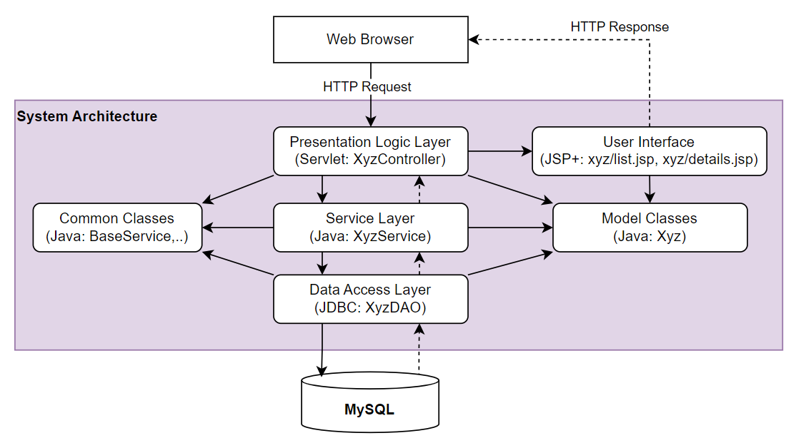

1.2 Component Descriptions
No | Component | Description
01 | Presentation Logic Layer | <Description of the component>
02 | User Interface | <Description of the package>
03 | …
-

2. Code Package Design
[Provide the package diagram for each sub-system. The content of this section including the overall package diagram, the explanation, package and class naming conventions in each package. Please see the sample & description table format below]

2.1 Package Diagram
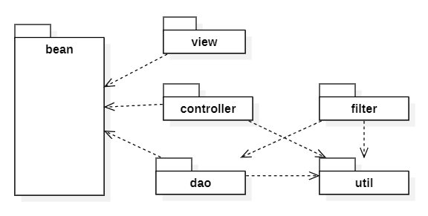

2.2 Package Descriptions
No | Package | Description
01 | View | <Description of the package>
02 | bean | <Description of the package>
03 | …

3. Database Design
[Provide the files description, database table relationship & table descriptions like example below]

3.1 Database Schema
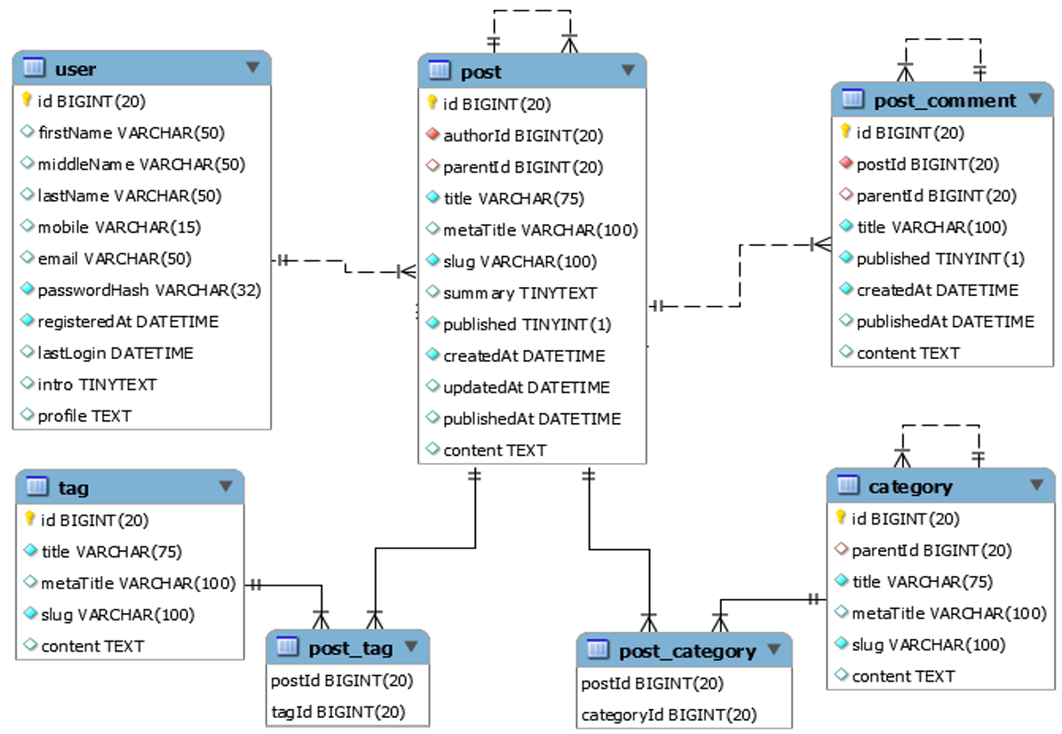

3.2 Table Descriptions

3.2.1 table_name1
[Provide brief description of the table here]
[Provide the detailed table fields description using below table format
* PK~Primary Key; FK~Foreign Key; UN~Unique; NN ~ not null
No | Field | PK | FK | UN | NN | Description
01 | <field_name1> |  |  |  |  | <Description of the field_name1>
02 | <field_name2> |  |  |  |  | …
..

3.2.2 table_name2
…

